**MADURAI**

**FOOTWEAR**

**ABSTRACT**

Footwear plays an important role in our daily life providing the functional support. This study explore the different categories of footwears, which includes casual, office wears, sport, climbing, highlighting the materials, design and innovations. Additionally this study analyzes the consumer preference and market trends, mainly focus on the factors of comfort, durability, sustainability and styles.

**KEYWODS**

Footwear shop-branch-people customize-brand-Type-Material-price range-budget-location

**WHY ANALYSIS ON FOOTWEARS**

We provide customizable options to help customers tailor their footwear shopping experience by selecting their preferred shop, location, material, brand, and price range. This ensures a more personalized and satisfying shopping experience.

**INTRODUCTION**

EDA(Exploratory data analysis) is used by data scientists to analyze and investigate data set and summarize their main characteristic, often employing data visualization. Identify relationships between variables. EDA is used for understanding the data, Identifying the patterns and trends, detecting anomalies and outliers, testing hypotheses, guiding further analysis and cleaning the data.

This paper analyzes data on various footwears brands and types in Madurai. The data was collected from shop owners and includes detailed information about their shop branches. The dataset has been created, tabulated, analyzed and visualized.

The primary objective of this data analysis is to understand consumers perferences for shopping based on the types of footwear, affordability, and quality within their local area. This analysis aims to ensure that customers can conveniently find high quality footwears at competitive prices in their vicinity.

**MANIPULATION OF DATA**

To handle the data we collected, we used tools such as Excel, Numbers and Tableau to turn it into useful information.

**BASIC MANIPULATION OF DATA**

By considering the available data set, we can do the basic manipulation by finding

* Footwear shop in Madurai
* Brands distribution in various shops.
* Material of footwear
* Types of footwear
* Minimum price of footwear
* Maximum price of footwear
* Availability of footwears
* Ownership of certain shops

**METHODOLOGIES**

We divided Madurai into different sectors to make our analysis more effective and easier to manage. This help us provide better insights and recommendations for each area. Footwear varied significantly across different shops. We began by analyzing six types of materials used in footwear at each location. Additionally, we collected data on the accessories associated with these materials and the corresponding brands. To understand consumer preference, we assessed the cost of footwear materials, identifying both maximum and minimum price.

**PRICE OF FOOTWEARS**

**TYPES OF MATERIALS**

We have examined six types of materials available in shops in Madurai.

|  |  |  |
| --- | --- | --- |
| **Row Labels** | **Sum of Price Min** | **Sum of Price Max** |
| Foam | INR 362,979 | INR 1,066,996 |
| Leather | INR 343,074 | INR 1,044,120 |
| Plastic | INR 342,035 | INR 1,054,914 |
| Rubber | INR 364,651 | INR 1,101,973 |
| Synthetic | INR 371,853 | INR 1,145,611 |
| Textiles | INR 384,282 | INR 1,210,303 |
| **Grand Total** | **INR 2,168,874** | **INR 6,623,917** |

Based on the collected data, we have determined the maximum and minimum prices for each types of material currently available in the whole market. In Madurai textiles are the most in-demanded material, particularly for producing knitted sneakers. However, foam and synthetic materials are also preferred by consumers due to the softness and comfort they provided

Leather ranks third on the list of preferred materials, primmarly because it is used to make formal shoes. Rubber ,however plays a curcial role in footwear, particularly in the production of flip flop, which are affordable and commonly used for daily wear. Rubber is highly preferred for its practically, while plastic, though low in cost has a shorter lifespan, leading to its lower preference due to its “use and dispose” nature.

This analysis provides a comprehensive understanding of the price range for these materials, aasisting in better decision-making for inventory management.

**AREAS IN MADURAI**

Based on the respective areas, we can obtain information about maximum and minimum price.

|  |  |  |
| --- | --- | --- |
| **Row Labels** | **Sum of Price Min** | **Sum of Price Max** |
| Annanagar | 2189 | 6691 |
| East Masi St | 3427 | 15169 |
| Kalavasal | 3110 | 8792 |
| KK Nagar | 1156 | 2354 |
| Koodal Nagar | 3613 | 12291 |
| Nagamalai | 2030 | 4605 |
| North Masi St | 766 | 1612 |
| Periyar | 3786 | 9874 |
| Simmakkal | 3984 | 11601 |
| South Masi St | 1787 | 4018 |
| Teppakulam | 4109 | 10825 |
| Tiruppalai | 3582 | 9281 |
| Vilangudi | 1494 | 3599 |
| West Masi St | 6804 | 20198 |
| **Grand Total** | **41837** | **120910** |

In Madurai ,west masi street is know for offering footwear at the higher end of the price spectrum, while north masi street offers more affordable footwear options. In anna Nagar the price of the footwears were depends on the brand. Basic footwears like causal and daily day uses were start from rs.300 to rs.500. Branded footwears were start from the price of rs.1000 to rs.5000.

Depending upon the brand and material they were chosen.

The footwears in east masi street were quit affordable. Footwears price range were budget-friendly starting. East masi street were popular for shopping, offering both branded and local. It is the ideal spot for traditional foootwears. In kalavasal footwears has the variety options for casual, formal and sports. The price range were depends about the brand and styles. In kk Nagar , popular shops for Bata, Madura footwears offering perimum foot wears. In Periyar footwears were offering for afforable price with good quality.

Footwear price vary across different areas, influenced by the economic status of the local population. This leads to the different price structure. Foot wear prices are also influenced by the demand and availability of shops in difference areas. In regions with limited competition often leads to higher prices. This scarcity plays a significant role in driving price difference across various localities.

Factor affecting footwears prices is the cost of logistics and transportations. In areas that are remote or difficult to access, the cost of shopping and handling can be higher. Which can contribute to increases prices. Additionally local taxes and tariffs can be vary from one region to another.

**BRANDS IN MADURAI**

The bar chart and tabulation of brands provide a clear and customizable overview, allowing for the selection preferred materials for specific brand to enhance their sustainability.

The above bar chart represents that reebok and Relexo exhibit maximum price range for footwears, while liberty and Nike demonstrate the minimum price range for footwears. Adidas, Bata, Puma and Paragan falls within the intermediate price range for footwears.

Currently ,Nike, Adidas and Puma are trending in the footwear market, with these brands being highly preferred by consumers.

Adidas is the German Sportwear company. Adidas is popular for athletic shoes and apparel, which offers the wide range of footwear types such as baseball players, runners, soccer. They provide a smooth and comfortable feel while playing.

Nike is the American company. Its also manufactures the sports footwears for athletes . Nike brand is famous for their Air Jordan shoes, Air force 1 and Air model shoes. Nike footwears are very comfortable to wear.

Puma is the German company famous athletic footwears. Puma rank one of the top brands with adidas and Nike. It popular for manufacturing legendary sneakers, its unique of heritage, innovation, cultural relevance.

|  |  |  |
| --- | --- | --- |
| **Row Labels** | **Sum of Price Min** | **Sum of Price Max** |
| Adidas | INR 6,078 | INR 18,999 |
| Bata | INR 4,852 | INR 18,396 |
| Khadim | INR 4,987 | INR 13,396 |
| Liberty | INR 2,910 | INR 6,441 |
| Nike | INR 5,550 | INR 12,131 |
| Paragon | INR 3,179 | INR 5,566 |
| Puma | INR 1,954 | INR 5,115 |
| Reebok | INR 5,177 | INR 17,307 |
| Relaxo | INR 2,280 | INR 8,618 |
| Woodland | INR 3,996 | INR 16,200 |
| **Grand Total** | **INR 40,963** | **INR 122,169** |

Bata is known for its comfort and affordability. So, in many countries people use it for their daily wear purpose. Its has unique styles and design.

Woodland is famous for outdoor and adventures footwears. It is made as rugged to face a up and downs in adventures.

Relaxo and reebok is the budget-friendly footwears comfortable to wear.

Liberty offers the wide range of footwear collections in casual, formal and also for athletics.

**SHOPS IN MADURAI**

The bar chart represents the sum of maximum and minimum price of footwears in Madurai market.

Footwear prices were trend to vary based on the location, with shops situated on the outskirts of town generally having higher price range. This is primarily due to increased demand in these areas, which drives up prices compared to stores in more central locations.

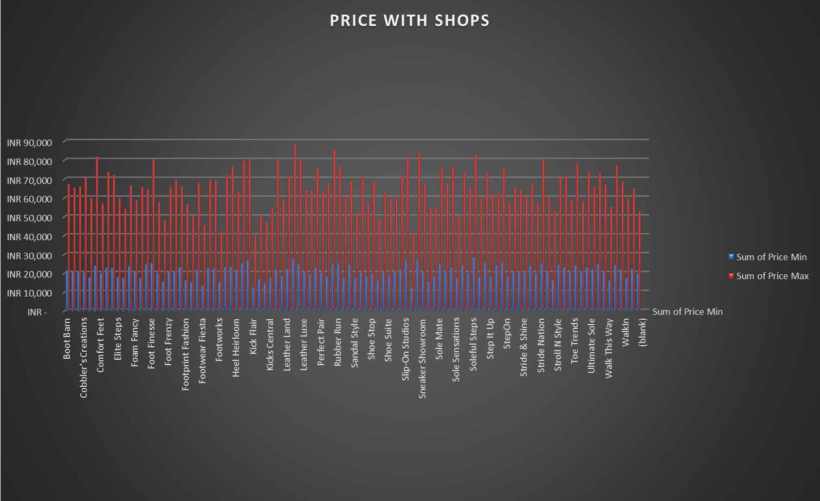

The variation in footwears in outer area were limited this is one the reason for maximum price range in outer most areas. The price range of footwear difference depends upon the seasonal sales.

Footwear shops are categorized into two types: small-scale and large-scale. The pricing of footwear in these shops is influenced by the surrounding market conditions. Shop owners factor in labor costs and offer a wide range of collections, including various brands and designs, which further impact the price structure.

**TYPES OF FOOTWEAR**

The given bar charts shows the maximum and minimum price range for types of footwears.

Casual shoes are priced higher due to their increased demand, as they are commonly used for daily wear. In contrast, formal shoes are predominantly worn by students and office-goers.

The primary factor influencing price variation is product demand. Footwear types with higher demand among consumers tend to have a higher price range in the market.

The key factor for price range of footwears

* Material quality
* Brand
* Design and craftmanship
* Demand
* Production cost
* Market location
* Target audience

Material has a major role price range of footwears. Higher quality of the material costs higher price. Next production cost, manufacturing complexity labor charge changes the prices range according to the types.

**RELATIONSHIP BETWEEN MATERIAL AND BRANDS**

The below bar represents the relationship between material and brands. The relation between brands and material plays a vital role in footwears. The below is bar chart helpful for consumers to understand that in which brand which material has the wide range of manufacture.

The footwears made from foam were soft and comfortable to wear. Adidas leads is highest position for manufacturing foam material, while woodland in the lowest position of manufacturing the foam material. Leather were most preferable material, relaxo stands in first for manufacturing the leather material. Woodland stands the second position in the manufacture of leather material. Adidas place in the last position on the manufacture of plastic. Adidas and Bata has the equal position in the manufacture of rubber material. Relaxo has the maximum range synthetic material manufacture. Textiles were highly manufactured by adidas.

**DHASHBOARD**

The provided dashboard effectively highlights the key insights and main points of this paper.

This dashboard presents a comprehensive overview of footwear shops in Madurai, including the available brands, types of footwear, materials and the corresponding price ranges both maximum and minimum. It also provides details on the stock availability in each shop, ownership information, footwear accessories, and the specific location of the shop

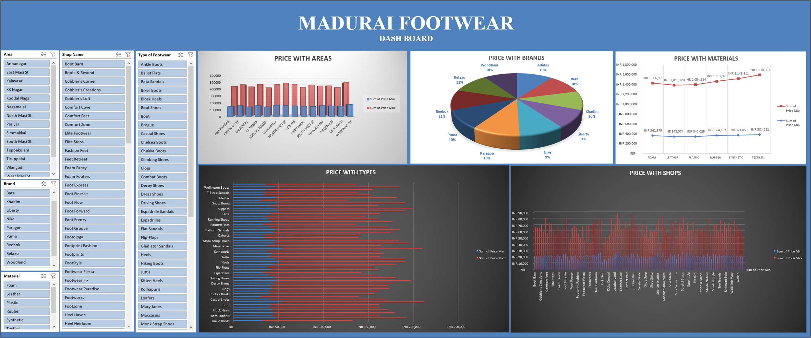

This dashboard enables users to customize their footwear selection based on personal preference.

For instance, if someone is looking for slippers, it identifies the area where they are sold. Additionally, if a customer seeks adidas slippers in Madurai, the dashboard provides a list of all adidas shops in the city, allowing for convenient and informed purchasing decisions.

This dashboard serves as a prototype for an app. Further development will transform it into a interactive dashboard or app, offering enhanced functionally to help the users personalize their shopping experience.

**CONCLUSION**

The footwear dataset enables the users to easily identify quality and price-appropriate footwear, thereby saving both time and money. The dataset also assists shopkeepers in showcasing their variety of brands, making it easier to reach consumer. Additionally, it contributes to providing a safe and secure shopping experience for customers

Further development of this dataset can evolve into a comprehensive footwear app, allowing users to locate shops and customize their footwear selections. The app will also offer the convenience of online purchasing, enhancing the overall shopping experience.

The development of this dataset into an app will also enhance the safety of online shopping, allowing users to purchase footwear with confidence, free from concerns about product quality, value, or potential fraud.

**RESULT**

We conclude that further development of this data can lead to the creation of an app or website that provides users with a more convenient and comfortable shopping experience. This data is highly valuable in ensuring that the app or website in development professionally and meets the needs of its users effectively.

**REFERENCE**

* [**https://www.sulekha.com/footwear-shops/madurai**](https://www.sulekha.com/footwear-shops/madurai)
* [**https://www.sulekha.com/footwear-shops/madurai**](https://www.sulekha.com/footwear-shops/madurai)

[**https://www.google.com/search?q=GOOGLE+MAP+LINK&rlz=1C1CHBD_en-GBIN1101IN1108&oq=GOOGLE+MAP+LINK&gs_lcrp=EgZjaHJvbWUyBggAEEUYOTINCAEQABixAxjJAxiABDINCAIQABiDARixAxiABDIKCAMQABixAxiABDIHCAQQABiABDIQCAUQABiDARiSAxixAxiABDIHCAYQABiABDIKCAcQABixAxiABDIKCAgQABixAxiABDIGCAkQRRhA0gEJOTY3NGowajE1qAIIsAIB&sourceid=chrome&ie=UTF-8**](https://www.google.com/search?q=GOOGLE+MAP+LINK&rlz=1C1CHBD_en-GBIN1101IN1108&oq=GOOGLE+MAP+LINK&gs_lcrp=EgZjaHJvbWUyBggAEEUYOTINCAEQABixAxjJAxiABDINCAIQABiDARixAxiABDIKCAMQABixAxiABDIHCAQQABiABDIQCAUQABiDARiSAxixAxiABDIHCAYQABiABDIKCAcQABixAxiABDIKCAgQABixAxiABDIGCAkQRRhA0gEJOTY3NGowajE1qAIIsAIB&sourceid=chrome&ie=UTF-8)